One-stage Tournament
Figures:
- Figure 1: Tel-PPO Framework

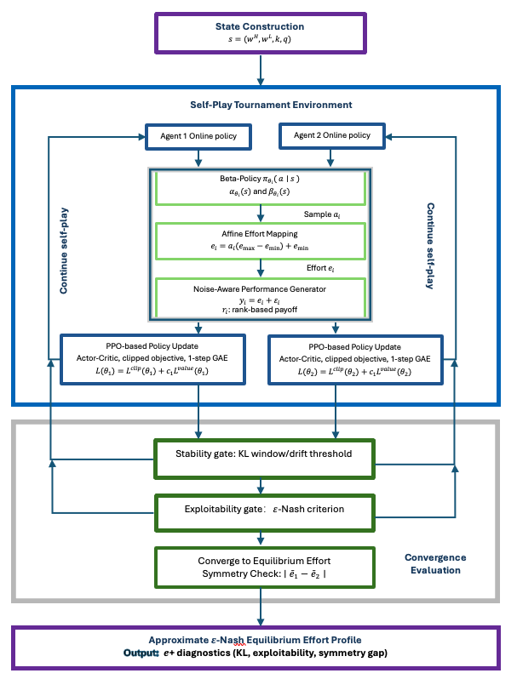

Static tournament primitives (degenerate one-step MDP); No state transitions across time; Independent agents with identical architecture (no parameter sharing); Continuous bounded action space via Beta distribution; Synchronous updates under self-play; Monte Carlo best-response search (common random numbers); Declared when criteria hold for consecutive evaluations; Diagnostic in symmetric settings only

- Figure 2. Two-player baseline under varying noise q:
a- Effort trajectory vs training (two sets of k & w value)
x-axis: training steps; y-axis: effort [0, 200]; two agents’ efforts: e_{1,} e₂, dashed line: theory e*; dotted line: $\frac{e_{1}+e_{2}}{2}$; panel labels: noise level q=; Convergence detection is indicated by a vertical line (or shaded region)?
b- Distance-to-equilibrium
x-axis: training steps; y-axis: |ē − e*|, different noise q
- Figure 3: Training stability diagnostics
a. Policy drift (KL)
x-axis: training steps; y-axis: approx. KL; line: target KL or thresh; shadow: rolling window
b. Effort drift
x-axis: training steps; y-axis: $∣\overset{ˉ}{e}(t)-\overset{ˉ}{e}(t-Δ)∣$($Δ$ = window length); line: drift threshold, window size, mean KL thresh / drift thresh
- Evolution of Beta policy distribution （two player baseline）
x-axis: effort; y-axis: density; three checkpoints: 10%, 50%,90%; two beta distribution with mean and variance
- Figure 5: Exploitability curve / Equilibrium verification
x-axis: training steps; y-axis: exploitability max; horizontal line $ε$; evaluation frequency (how many PPO updates)
- Equilibrium Recovery Across Tournament Structures: Dot Plot with theory line
x-axis: scenario (Two-player, Three-player, Heterogenous ability, heterogeneous cost)
y-axis: learned equilibrium effort; theory line.
TEL-PPO recovered effort: symmetric case-one dot (mean effort); heterogeneous cost-one dot for low-cost agent, one triangle for high-cost agent (e₁, e₂)
Theory e*: short line

Table:
- Environment configuration
Parameter | Value/Description
(High prize $w_{H}$, Low prize $w_{L}$) | (6.5,3), (8,4)
Cost parameter | $$k=0.0004$$
Action/Effort bounds | $$\left[e_{min} , e_{max}\right]: [0,200]$$
Noise distribution | $$ε_{i}∼U[-25,25],U[-40,40],U[-55,55]$$
Hyperparameter | Learning rate, batch size, clip, seeds?  held constant across experiments unless stated?

- Quantitative summary of equilibrium recovery
Scenario | q | Method | Mean $±$ std？ | $$∣\overline{e}-e^{*}∣$$ | Exploitability | Symmetry gap | Steps to convergence

- Ablation
Variant | TEL-PPO | +Entropy | No stability gate | No exploitability gate
Final error
exploitability
Steps to convergence
Failure mode
Failure mode: diverge/ cycle / biased mean / never terminate

